**1. Start project (command line)**

VIRTUAL ENV MUST BE ACTIVATED!

DJANGO MUST BE INSTALLED!

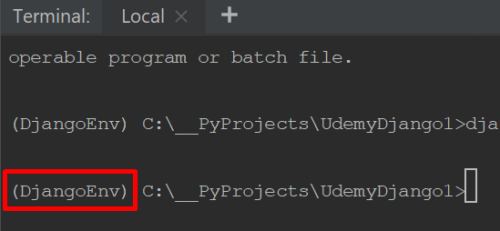

**COMMAND:**

django-admin startproject [project name]

**Result:**

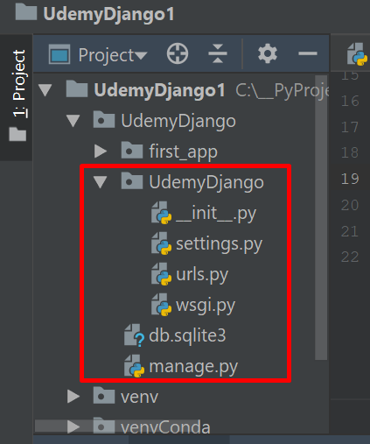

**2. Start app**

python manage.py startapp [app name]

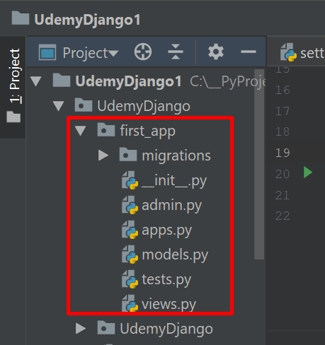**Result:**

**3. Important import/changes**

vievs.py:

from django.shortcuts import render  
from django.http import HttpResponse  
  
def index(request):  
 return HttpResponse('Hello World!')

urls.py:

from django.contrib import adminfrom django.conf.urls import urlfrom django.urls import pathfrom [app name] import viewsurlpatterns = [ url(r'^$', views.index, name='index'), path(r'^admin/', admin.site.urls),]

settings.py:

INSTALLED_APPS = [ 'django.contrib.admin', 'django.contrib.auth', 'django.contrib.contenttypes', 'django.contrib.sessions', 'django.contrib.messages', 'django.contrib.staticfiles', '[app name]']

**4. Templates**

a) Create new folder under Main folder:

// AppFolder

**// templates**

// DjangoProjectFolder

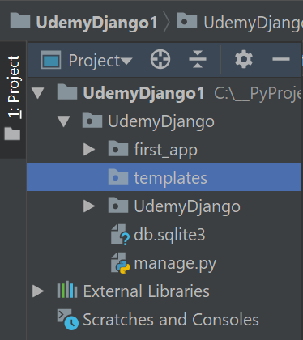

b) settings.py:

– Add new variable: TEMPLATE_DIR = os.path.join(BASE_DIR,'templates')

– Insert the variable in TEMPLATES dict:

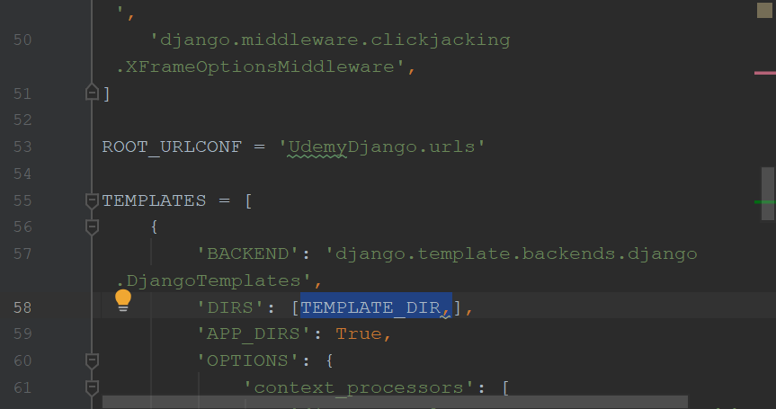

**5. Static**

a) Create new folder under Main folder:

// AppFolder

**// static**

// DjangoProjectFolder

b) settings.py:

– Add new variable: STATIC_DIR = os.path.join(BASE_DIR, 'static')

– Add new list: STATICFILES_DIRS = [STATIC_DIR,]

